Code logics – check code fully with comments
https://www.hellointerview.com/learn/code/
July 4 – two pointer, sliding window & interval
July 5 – stack, linked list & binary search
July 6 – heap
July 7 – DFS
July 8 – BFS
July 9 – backtracking
July 10 – graphs
July 11 – dynamic programming
July 12 – greedy algorithm & trie
July 13 – matrices
July 14 – DFS
July 15 – BFS
July 16 – Dynamic Programming

Neetcode.io
Takeyouforward – youtube channel

Subtraction can overflow:
A Java int can only store values from:
-2,147,483,648 to 2,147,483,647
If a calculation goes outside this range, Java does not throw an exception. The value wraps around.
Overflow example
int a = -1;
int b = Integer.MAX_VALUE; // 2,147,483,647
int result = b - a;
System.out.println(result);
Mathematically:
2,147,483,647 - (-1)
= 2,147,483,648
But 2,147,483,648 is larger than the maximum int, so it wraps to:
-2,147,483,648

Avoid comparators such as:
(a, b) -> b - a
because subtraction can overflow. Prefer:
Comparator.reverseOrder()
or:
(a, b) -> Integer.compare(b, a)

Two pointers
This technique refers to using two pointers that start at opposite ends of an array and gradually move towards each other.
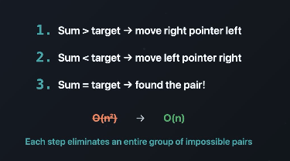
The two-pointer technique leverages the fact that the input array is sorted to eliminate the number of pairs we consider from O(n2)down to O(n).
The two-pointers start at opposite ends of the array, and represent the pair of numbers we are currently considering.
We repeatedly compare the sum of the current pair to the target, and move a pointer in a way that eliminates unnecessary pairs from our search.
Examples:
- Finding a pair of items that sum to a given target in an array.
- Finding a triplet of items that sum to 0 in a given array.
- Finding the maximum amount of water that can be held between two array items representing wall heights.
Problem 1: Container With Most Water
Array is not sorted, we will focus on wider width so we will get more area. Starts with first and last index and the height is minimum of these 2 index value. Calculate area keep it as tmp for comparison. If start index height is less then increase start index, if end index height is less then decrease right, if both are same then decrease right. Iterate until start<end.
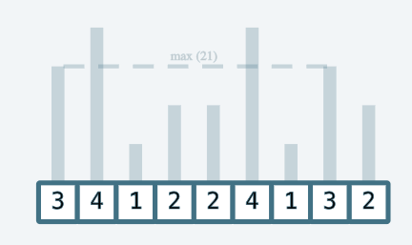

Problem 2: Three sum – unique triplets whose sum should be 0
First sort the array, pick one value then use two pointer technique to complete the triplet. Handle duplicate at both level.

Problem 3: Valid Triangle – to form a valid triangle summing any 2 side of the value should be greater than other side .
First sort the array, pick last element as i
Condition is a+c >b, b+c >a and a + b > c
Since we are taking larger number as I i.e c, summing with any number with c will obviously greater than the number which is lesser than c, so a+c >b, b+c >a these 2 conditions we don’t need to worry because array is sorted and largest number is considered as c.

Problem 4: Move zeros – move all zeros to the right of the given array, don’t use new array
We can solve this problem by keeping a pointer i that iterates through the array and another pointer nextNonZero that points to the position where the next non-zero element should be placed. We can then swap the elements at i and nextNonZero if the element at i is non-zero. This way, we can maintain the relative order of the non-zero elements while moving all the zeroes to the end of the array.

Problem 5: Set Colors – given array of values containing only 0,1 and 2, we need to sort the array
Conditions: sorting should be done in same array with order(n)
Brute force solution will be, pass one to count how many 0’s, 1’s and 2’s
pass two rewrite the array from left to right – we write count of 0’s and count of 1’s and count 2’s
this works but it is taking two passes in the array, we can make it in one pass.
Solution:
Take 3 pointers. i, left, right
Left pointer represent 0 zone and right pointer represent 2 zone and i represent unsorted zone
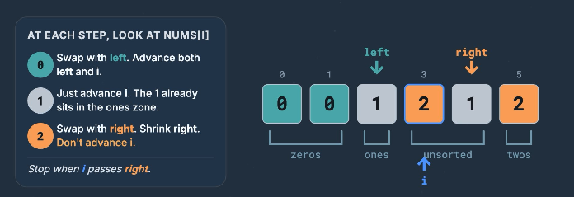
If value of I is 0 – swap with left, increment both I and left
If value of I is 1 – just advance I, the 1 already sitting in one zone
If value od I is 2 – swap with right, decrement right. DON’T increment I because I is from unsorted zone and still need to check that value

Problem 6 – Trapping rain water
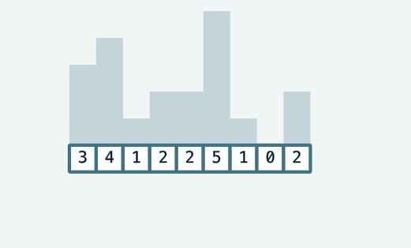
We need to store water within these bars. We will use two pointers left, right and 2 variables leftMax and rightMax. In order for any index in the array to be able to trap rain water, there must be higher bars on both the left and right side of the index.
https://www.hellointerview.com/learn/code/two-pointers/trapping-rain-water - check here for understanding

Sliding Window
This technique refers to creating a window that "slides" through an input sequence (typically an array or string). Sliding windows can be either variable or fixed length.
Fixed-Length Sliding Window:
When you know the length of the subarray/substring you are looking for, you can use a fixed-length sliding window. The concept is similar to the variable-length sliding window, but the implementation is a bit simpler, as during each iteration, you both add and remove an element from the window to maintain its fixed size.

Given an array of integers nums and an integer k, find the maximum sum of any contiguous subarray of size k.
Example: Input: nums = [2, 1, 5, 1, 3, 2], k = 3 Output: 9 Explanation: The subarray with the maximum sum is [5, 1, 3] with a sum of 9.
We start by extending the window to size k. Whenever our window is of size k, we first compute the sum of the window and update max_sum if it is larger than max_sum. Then, we contract the window by removing the leftmost element to prepare for the next iteration. Note how we calculate the sum of the window incrementally by adding the new element and removing from the previous sum.

Variable length sliding window:
In fixed length we will change the window’s start and end index if window reaches the size k, but in variable length whenever a condition matches we will change the window start index.

Intervals – (employee free time program pending)
(meeting rooms, calendar scheduling, task overlap, non overlapping intervals)
Interval – think of it like a meeting in your calendar 9 to 11, we represent this as [9,11] the start and end numbers.
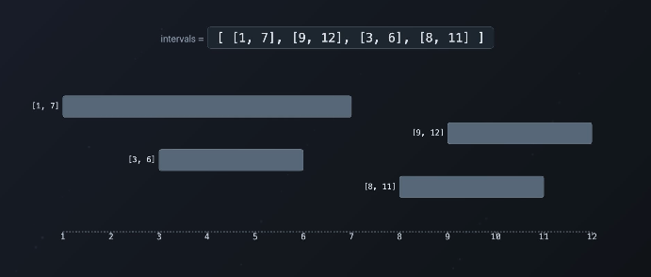
Three patterns in this intervals, they all share one key trick. Sort the intervals first then process them. Choice we have to make here is do we need to sort by start (detect overlaps, merge intervals) and sort by end(maximize non overlapping count.
1)Do any interval overlap? (can attend all the meetings)
Sort by start time, if we sort the intervals by start time those will be in chronological order, go through them one by one.
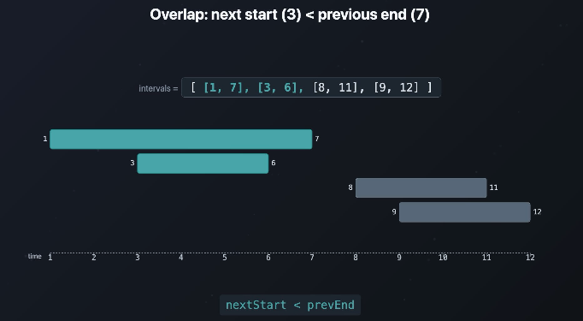
Second meeting starts before first meeting ends i.e nextStart < prevEnd, this means 2 meetings are happening same time.

2)Merge overlapping intervals into one
Sort by start time and merge overlapping intervals. This will give non overlapping clean list.
If overlapps, new end = max(prevEnd, currEnd)

3)Maximum non-overlapping intervals : attend as many as possible
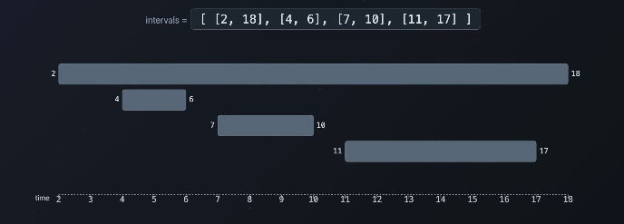
Sort by start is WRONG tool, for above example if we sort by start then 2,18 is the only meeting I can attend, but I need the maximum number of meetings I can attend, so we need to sort by interval end.
[ [4,6], [7,10], [11, 17], [2, 18] ] – sort by interval end, this way without overlapping I can attend 3 meetings.

Java code snippet for learning
List<int[]> merged = new ArrayList<>();

merged.toArray(new int[merged.size()][])

new int[3][]
creates space for three int[] references:
[
null,
null,
null
]
toArray() then fills those positions using the arrays from merged.

new int[3][2]
which immediately creates three new arrays, each containing two integers:
[
[0, 0],
[0, 0],
[0, 0]
]

LinkedList
To detect cycle – take 2 pointers – slow and fast – both starts at head, slow moves by one node and fast moves by 2 node. If slow and fast pointers meets then there is a cycle. If fast pointer reaches null then there is no cycle.
Palindrome linked list:
Use 2 pointers – slow and fast – both starts at head, slow moves by one node and fast moves by 2 node. At the time fast reaches end slow will be in mid point. For a palindrom number, numbers before mid point should match with REVERSE order of numbers after mid point. So after finding the mid point reverse second half and then compare values with 1st node with mid+1st, 2nd with mid+2nd like that. If matches palindrome else not a palindrome.

BinarySearch:
In binary search array is sorted. To search an element take mid, compare it if it is equal return index, if target is less than mid then ignore elements right side of the mid point, so take mid point from start to mid, if target is greater then ignore elements which are left side of the mid point because the array is sorted all left side values are smaller than mid. Repeat it until mid matches the target.
This is very efficient, complexity is O(log n), for 1 billion elements it will take only 30 comparisons because log2(1000000000) is 29.9

Heap:
What if the smallest element always sit at first in the array, no sorting needed that is called heap. Heap is just an array where smallest element always sit at index 0, if we remove smallest element then next smallest will come to index 0. Eventhough it is a flat array, it is easy to understand if we represent it as binary tree.
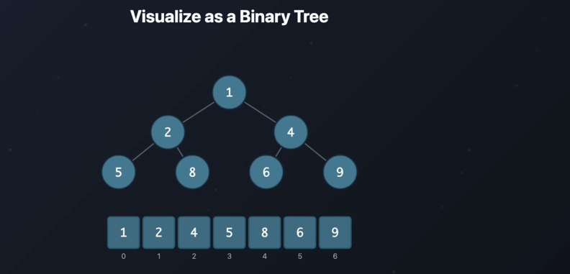
Given array is valid heap, how it is represented in the tree is, first node is the root, then next 2 nodes will come in next layer. Values will be filled layer by layer. One thing to note here is every parent is smaller than both of its child node. This is called MIN-HEAP.
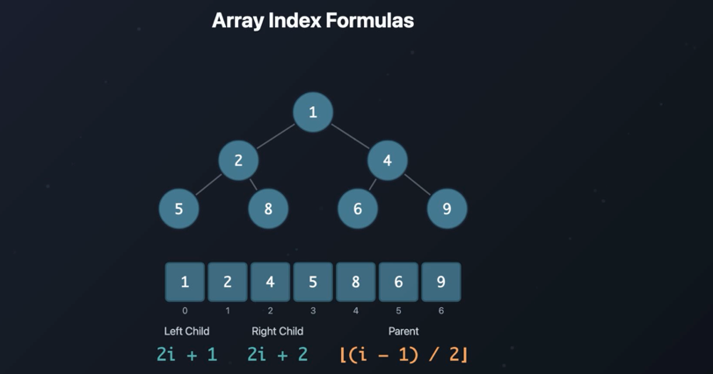
Array index formula
Left child - 2i + 1
Right child – 2i + 2
Parent – Lower(i-1)/2
Here i is the index of the element
To find left and right child of 2
Element 2 is at index 1
Left = 2i + 1
= 2*1 + 1
= 3 element which is in 3rd index is the left child of node 2
Right = 2i + 2
= 4 element which is in 4th index is the right child of node 2
To find parent node of 6
Element 6 is at index 5
Parent = lower((i-2)/2)
= l((5-2)/2)
= 2 element which is in 2nd index is 4 which is the parent of 6
Heaps are complete binary trees, every level is fully filled except last level.
MAX heap: every parent is greater than or equal to its children
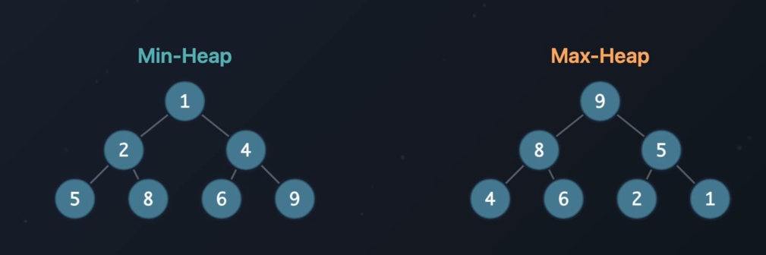
Heaps overpowers priority queues. It can be used for priority queues (grab the most important item), shortes path (Dijkstras algorithm), Merge k list(smallest head at each step), Running median (two heaps one answer)
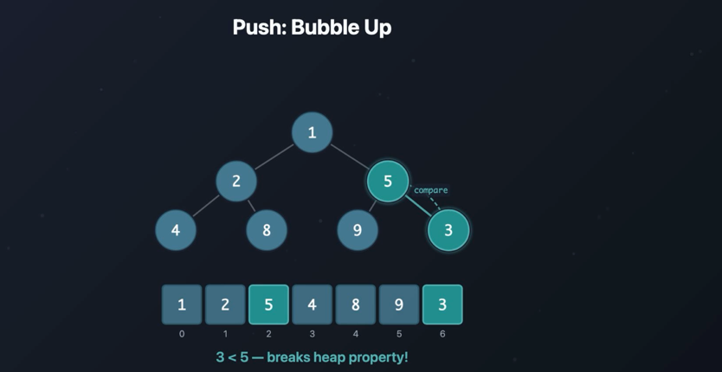
There are 2 operations in the heap, push and pop. While doing push number is added at last in the array, then it will compare it with its parent, in above case we are adding 3 and its parent is 5 and it is a min heap so parent should be smaller than its children and it is breaking that rule so swap it, now new parent is 3 and its children are 9 and 5 this matches with min heap property. 3’s parent is 1 which is already smaller than 3 so heap property is fine. This process is called bubble up – the new elements swaps upward until it finds the correct spot.
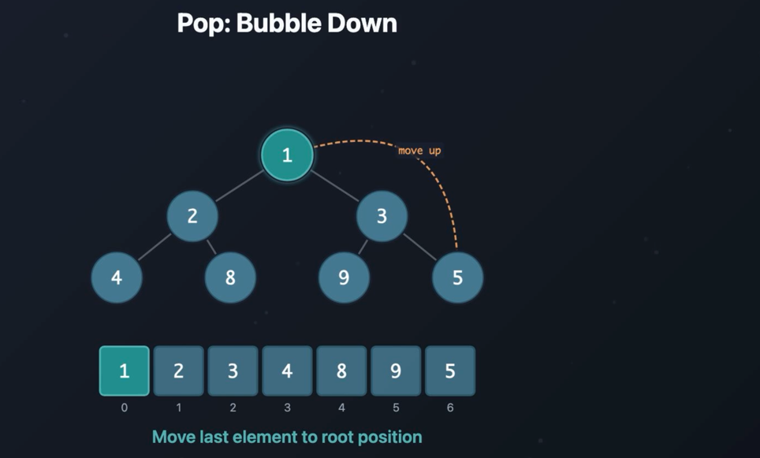
In heap pop is always root element, while popping root, last element in above case 5 is moved up to root. Now 5 is bigger than both of its child, so it gets swapped with SMALLER element
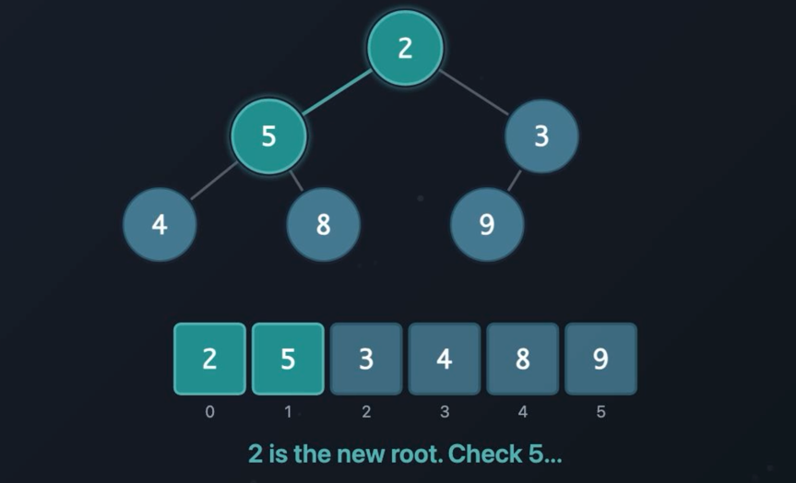
Now 5 is bigger than one of its child so it gets swapped with smaller one, this process is called Bubble down.
Heapify: Build a heap in O(n)
Take random array and turn it into valid heap (in place without exta memory)
- Start from last node which has children
- Works backwards towards the root
- Bubble down each node into position
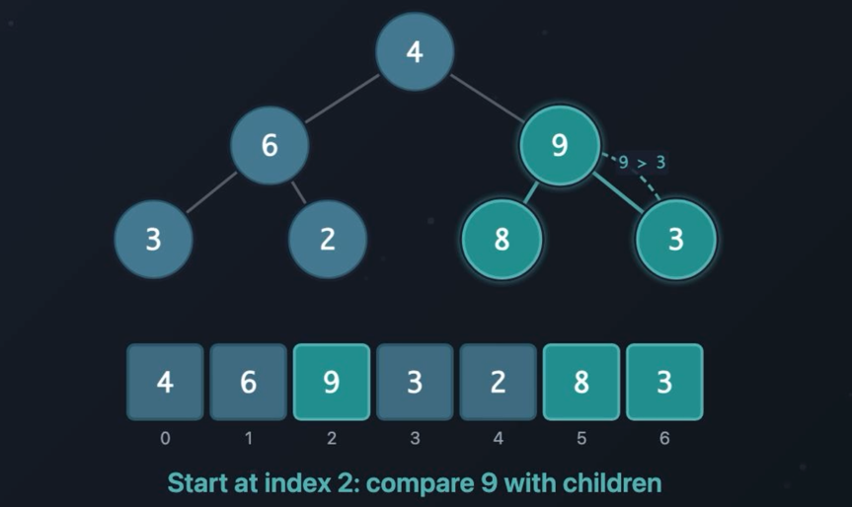
Starts with right side last node which has children, if parent is greater than both of its children then swap it with smaller, then move to left side node and repeat same process.
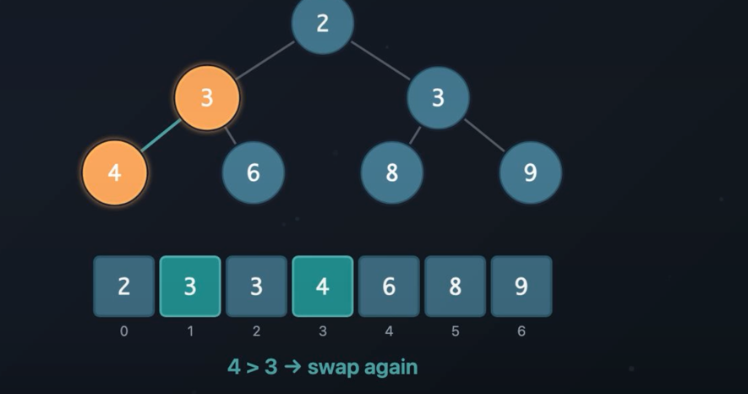
The top K pattern:
Given an array find the K largest elements. Brute force is sort the array and get last K elements. This is O(n log n), we can accomplish this with O(n log k) using min heap.
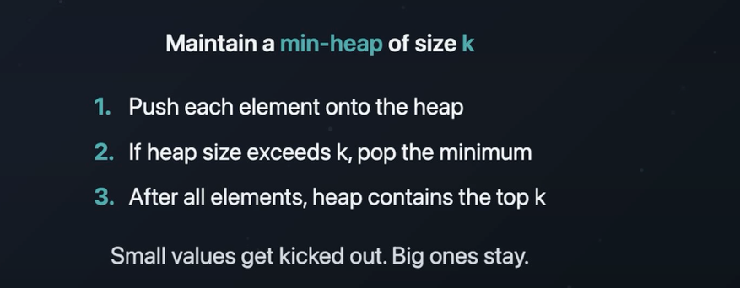
Why min heap – in min heap root element will be smaller and we need largest K so using min heap is the correct solution, if we need smallest K then we need to use max heap.

DFS:
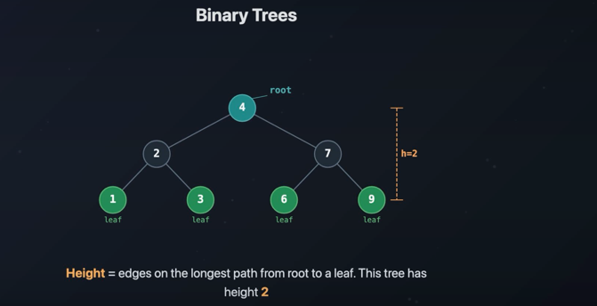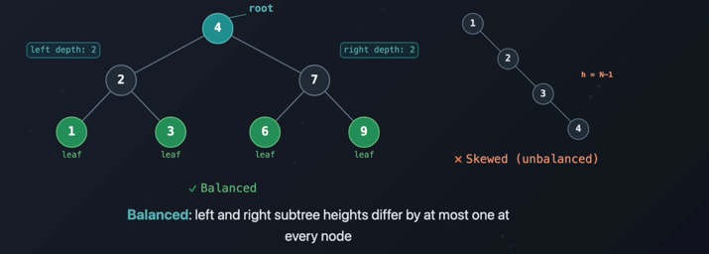

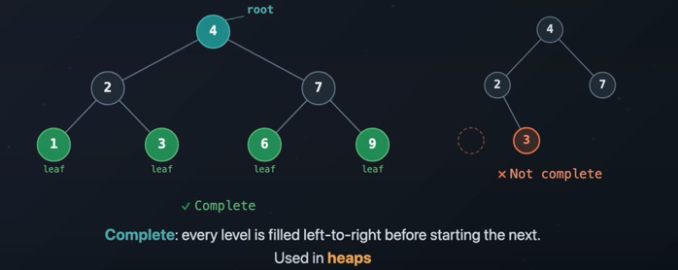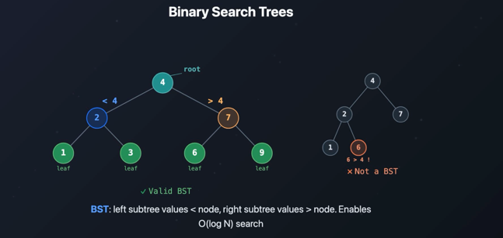
Dfs achieves backtracking using recursion. The base cases stops us from going past the leaf nodes.

Recursion:
Every function call is stored in a memory structure called the call stack.
public class RecursionExample {

static void countDown(int number) {
// Base case: stop recursion
if (number == 0) {
System.out.println("Finished");
return;
}

System.out.println(number);

// Recursive call with a smaller problem
countDown(number - 1);
}

public static void main(String[] args) {
countDown(3);
}
}
What is the call stack?
The call stack stores information about active function calls.
Each function call creates a stack frame containing:
- Function parameters
- Local variables
- The location to return to
- Other execution information

Step-by-step execution
The program starts with:
countDown(3);

Step 1: Call countDown(3)
Call stack:

┌────────────────┐
│ countDown(3) │ ← top
└────────────────┘
│ main() │
└────────────────┘
It prints 3 and calls:
countDown(2);

Step 2: Call countDown(2)
The previous call is paused. A new frame is added:
┌────────────────┐
│ countDown(2) │ ← currently running
├────────────────┤
│ countDown(3) │ ← paused
├────────────────┤
│ main() │
└────────────────┘
It prints 2 and calls countDown(1).

Step 3: Call countDown(1)
┌────────────────┐
│ countDown(1) │ ← currently running
├────────────────┤
│ countDown(2) │
├────────────────┤
│ countDown(3) │
├────────────────┤
│ main() │
└────────────────┘
It prints 1 and calls countDown(0).

Step 4: Reach the base case
┌────────────────┐
│ countDown(0) │ ← base case
├────────────────┤
│ countDown(1) │
├────────────────┤
│ countDown(2) │
├────────────────┤
│ countDown(3) │
├────────────────┤
│ main() │
└────────────────┘
The condition is true:
if (number == 0)
It prints Finished and returns.

Removing calls from the stack
After countDown(0) returns, its frame is removed:
countDown(0) returns
countDown(1) continues and returns
countDown(2) continues and returns
countDown(3) continues and returns
main() continues
This is called unwinding the stack.

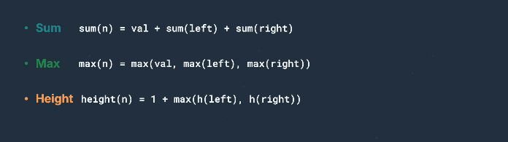

BFS – breadth first search – it goes level by level
BFS achieves this by using queue data structure. Create an empty queue and add root node into the queue. Lopp until queue is empty.
- Remove first element from queue (this is visited – to track we can add it in separate list)
- If removed node has left child then add it to queue
- If removed node has right child then add it to queue.

Backtracking:
Explore all possible paths to find a solution, backtracks as soon as a path cant lead to an answer. Backtracking = DFS + undo. DFS goes as deep as possible in branch then backs up and try the next. Backtracking is with one additional ability to undo the steps. In dfs we just traverse the nodes, in backtracking we make choice at each step, validate the step and undo the choice before trying next option.

Solution space tree:
Letter combination: Build the tree with empty string as root before writing code
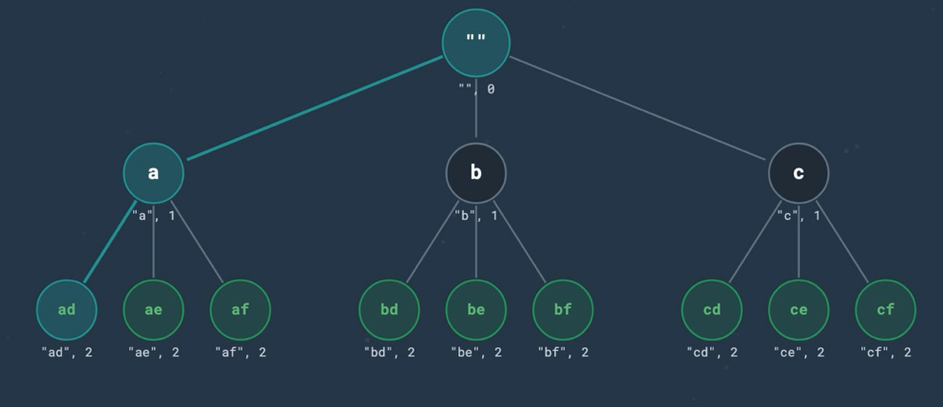
Subsets: at each level choose or skip the next element
Permutation: each level picks from the element which are not yet used

The first step in solving a backtracking problem is to visualize the solution-space tree.
- Each node in the solution-space tree corresponds to a single recursive call.
- The parameters of the recursive function correspond to the information needed to reach the neighbors of a node.
- The body of the recursive function should iterate over the neighbors of a node and make recursive calls for each neighbor.

Graphs topological order
It is used in build systems to decide which file to compile first, also used scheduler to decide which task to run before others.
DAG – Directed Acyclic Graph – directed graph without cycle
Topological order takes a DAG and produces a linear ordering of the nodes. The rule is simple for every U -> V, U must come before V.
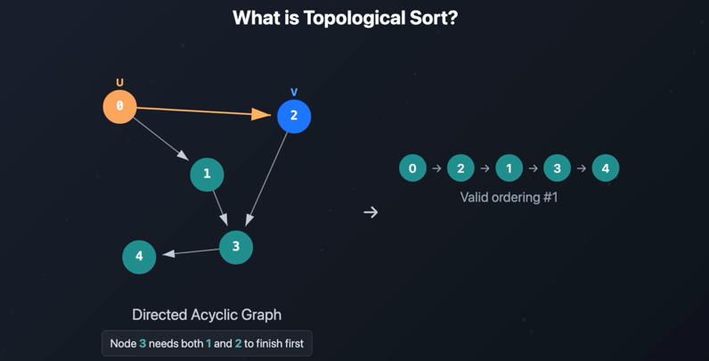
From this screenshot, to run node 3 node 1 and 2 must be completed. Think of it like task with a dependency. To run task 3, task 1 and 2 must be completed. There are 2 important rules
- Graph should be acyclic (because if there is a cycle then every U -> V, U must come before V. this can not satisfy)
- There must be more than on valid combination. In above case there are 2 valid combination
0->2->1->3->4 and 0->1->2->3->4

Indegree: number of incoming edges to a node
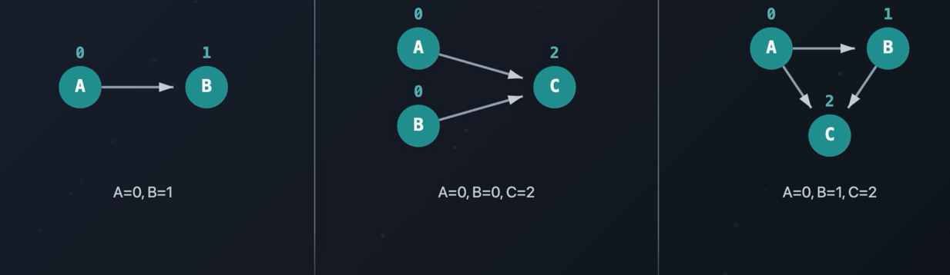
A node with 0 indegree has no dependency, that is nothing need to start before it. To calculate indegree, iterate through every edge in the graph, for each edge from U->V, increment V’s indegree by one.
Khans Algorithm:
It is a BFS based approach for topological sort. Simple idea is start with node which has indegree 0 and fill layer by layer. Steps
- Calculate indegree to every node
- Add all node of indegree 0 to the queue
- While queue is not empty, dequeue a node, add it to the topological order, then look at all of its neighbors and decrement the indegree by one. If any neighbors indegree drops to 0 then add it to the queue
- Return the topological order.
Each time you are moving a node, you are effectively telling that this task is done, so it dependents now has one lesser prerequisite. When a dependent has 0 prerequisite left then it is ready to go.
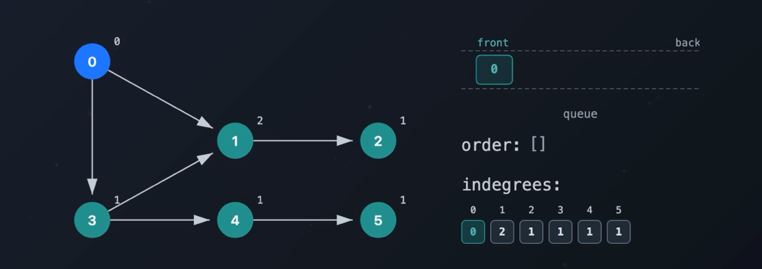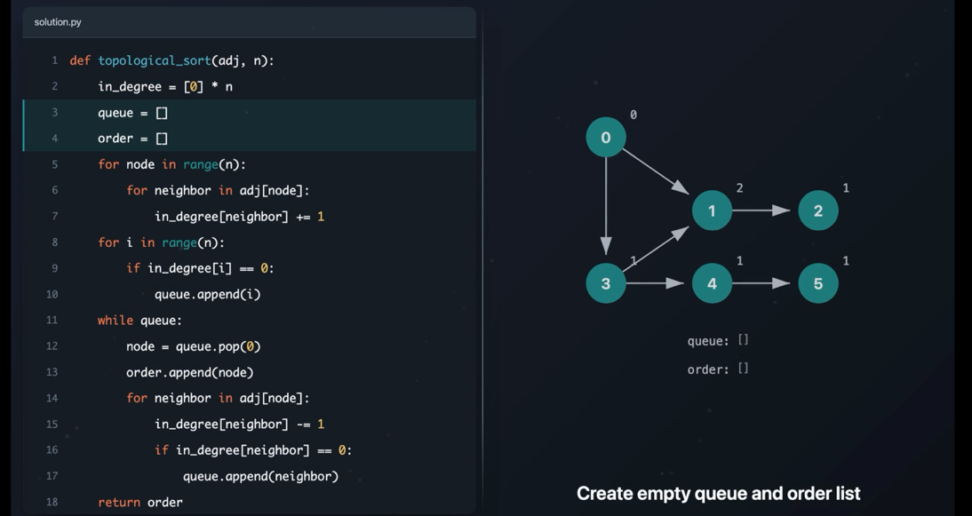

Dynamic Programming:
Core idea is simple, don’t solve the same problem twice. Consider a climbing step problem. At each time you can climb 1 step or 2 steps, then how many distinct ways to reach the top. For n=3 there are 3 ways.
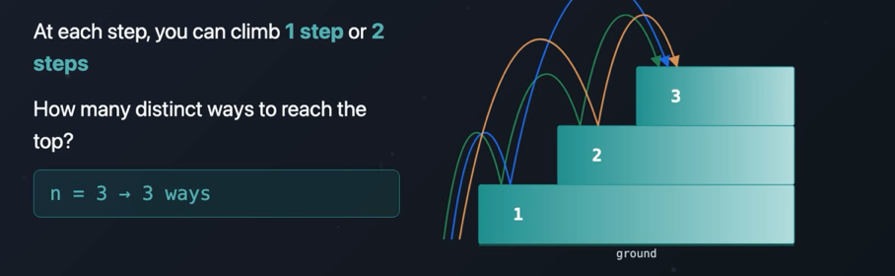
Brute force: recursion
If you are standing in step n then how you would have reached there, 1. You would have took one step from n-1 or you would have took 2 steps from n-2. So the answer is s(n) = s(n-1) + s(n-2).
For n=5, the call stack would be like below
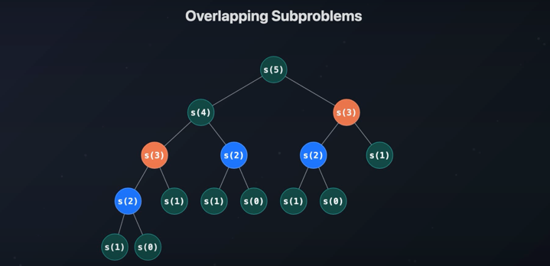
Here we are solving s(3) two times and s(2) three times, this is called overlapping sub problems. Fix is memorization (cache result), create a map, before invoking recursion check if the result is already there in the map, if yes then return it else compute it and store it in the map then return the result.
Memoization is top down approach, there is also a simple bottom up approach called tabulation, in tabulation start from the base cases and build up to n.
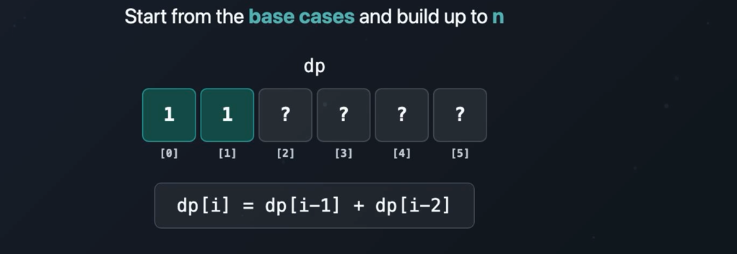
In tabulation there is no recursion call and no storage, simple. But if you see it closely we are using only last 2 values to compute current value, so why keep full array, we can simply have 2 variables(prev1, prev2)
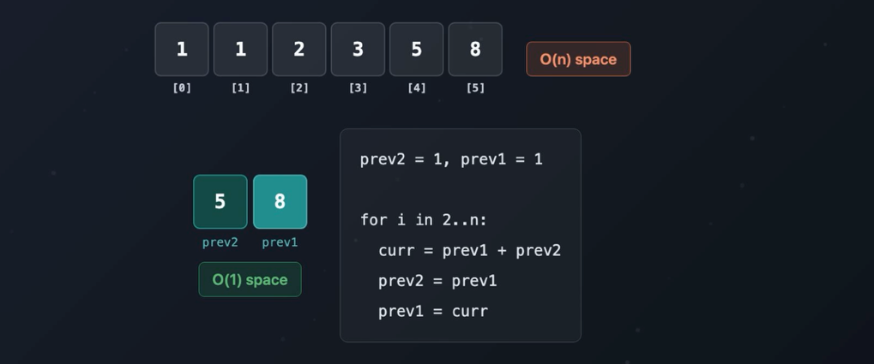
Steps to solve the program with DP
- Find the Recurrence Relation
- Identify the Base Case(s)
- Write the Recursive Solution
- Add Memoization
- Convert to "Bottom-Up" DP
- Further Optimization

Greedy algorithm:- make the best choice right now and trust that it works
Example problem – greedy children assign cookies
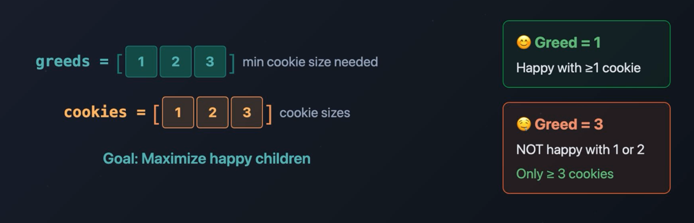
Greeds array will have children’s greed, 1 means that children will satisfy for cookie size >=1, 3 mens that children will satisfy for cookie size >=3. One child can not have 2 cookies also one cookie can not share with 2 children. If we give big cookie to smaller greedy child then we are wasting that cookie, so we can not give randomly. We need to satisfy the least greedy child first using the smallest cookie that work, don’t waste big cookie for easy to please child. If we sort both array then we can achieve this.
First test whether greedy is safe.
If you can find a counterexample(This greedy strategy does not work.
), abandon that greedy strategy.
Then check whether the problem has optimal substructure and overlapping subproblems.
If yes, use dynamic programming.

It means: when you face a problem where you need the best / minimum / maximum answer, don’t immediately jump to code. First ask:
Can I make the best local choice now and still get the best global answer?
That idea is called the greedy choice property.
Greedy Meaning
A greedy algorithm makes the choice that looks best right now.
Example:
At each step, pick the biggest coin.
At each step, pick the shortest job.
At each step, pick the item with highest value.
Greedy is attractive because it is usually simple and fast. But it only works for some problems.
Greedy Choice Property
A problem has the greedy choice property if:
A locally best choice can safely be part of a globally best answer.
In simple words:
If I make the obvious best choice now, I will not regret it later.
Example where greedy works: interval scheduling.
Problem: choose maximum number of non-overlapping meetings.
Greedy strategy:
Always pick the meeting that ends earliest.
This works because choosing the earliest-ending meeting leaves the most room for future meetings.
Counterexample Meaning
A counterexample is a small input where your greedy idea fails.
If you find even one case where greedy gives a worse answer, that greedy strategy is invalid.
Example: minimum coins.
Coins:
1, 3, 4
Amount:
6
Greedy picks the largest coin first:
4 + 1 + 1 = 3 coins
But the best answer is:
3 + 3 = 2 coins
So greedy fails.
That counterexample tells you:
Do not trust this greedy approach.
You may need dynamic programming.
Why Dynamic Programming
Dynamic programming is useful when a current choice affects future choices, and you need to compare multiple possibilities.
For the coin example, instead of blindly choosing 4, DP tries possibilities:
Use coin 1
Use coin 3
Use coin 4
Then it builds the best answer from smaller amounts.
For amount 6:
dp[6] = 1 + min(dp[5], dp[3], dp[2])
That way DP discovers:
dp[6] = 2 using 3 + 3
Greedy vs DP
Think of it like this:
Greedy:
Pick what looks best now.

DP:
Try choices, remember results, and choose the best overall.
Greedy is faster but only works when local decisions are safe.
DP is usually needed when:
- choices affect future options
- greedy can get trapped
- the problem asks for min/max/count ways
- subproblems repeat
- optimal answer can be built from smaller optimal answers

Trie
Auto complete, prefix matching, spell checkers these are common trie patterns.
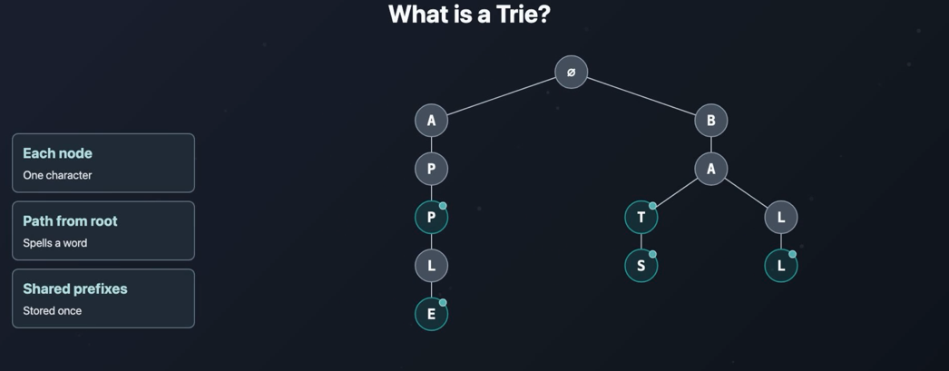
A trie is also called as prefix trees. It stores a collection of strings in a tree structure. Unlike regular tree, in trie each node contains single character. We can build words by following a path from root down to the tree. Above trie stores 5 strings (apple, app, bat, bats and ball). Root sits at the top with no char, and it will have 2 childs A and B one for each unique starting letters. Under A there is P and P (2 nodes), at this point APP is an complete word, so we mark it. Same way for other words also we will mark the node if it is a complete word. Apple and app share the same nodes APP. They share common prefix, and the tries stores the prefix only once. This is the whole point of trie. Strings with same prefix share the same path through the tree. This saves memory and prefix based searches faster. Each node will have “isEndOfWord” Boolean, if it is true then the path from the root down to this node forms a complete word. Without this Boolean we can not tell the difference between prefix and complete word. Root node is special which does not have any character and holds only children one for each unique first character of the word we are storing in the trie. There are 3 operations we can do in trie – search, insert and delete.
Search:
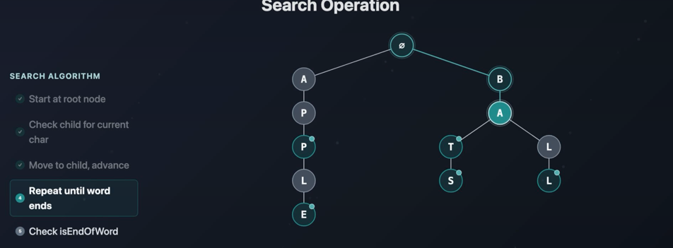
Search given string is there in the trie. We will start at root and check child for current char, if it is there move to child and repeat until word ends. After input word ends check the node is marked as isEndOfWord to true. If yes then search is success else the given input is not a valid word and return false.
Insert:
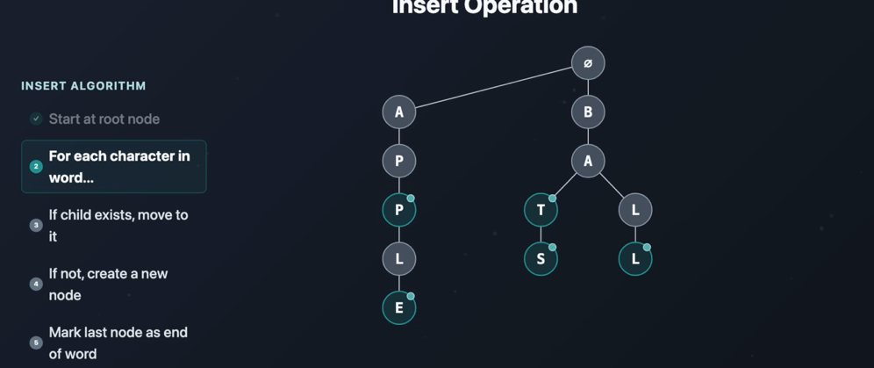
Start at root node and for each character in the given word check if child exists, move to it else create new node. Mark last node as end of word.

Delete:
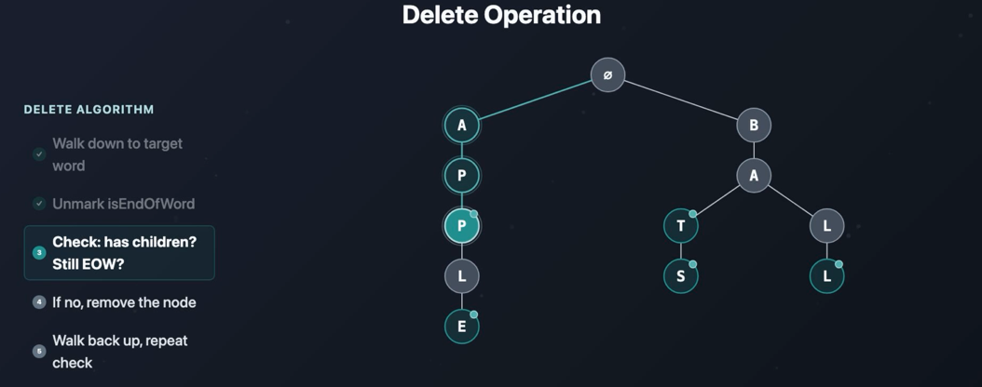
Start from root and walk down to target word.
Unmark isEndOfWord flag
Check that node has any children, if yes then we can not remove the node – for example if we are removing APP from above trie we can not remove app because it is a prefix for APPLE, so we just unmark the node that it is not end of word, so in search it can return not found.
If node has no child then we can remove that node and walk back and check if that node is marked as end of word if yes stop the process else remove that node also(because that is part of this word only) and repeat the process. WE CAN ONLY REMOVE NODE IF IT HAS NOT CHILD. To remove BATS, walk down to S and unmark the node and remove node S because it has no child then walk back to T. this is marked as end of word so we can not remove that node and process ends. If T is not marked as end of word then we can remove T and walk back to A, since A has child we cannot remove A and end the process.

Prefix sum:
To calculate sum of sub array, we first iterate the array and store sum of all previous elements in result array. To find the sum of sub array [2:4] then, we just get values from result array for 4 and 2 and subtract. This would be helpful for finding sum for sub arrays repeatedly.

Graph
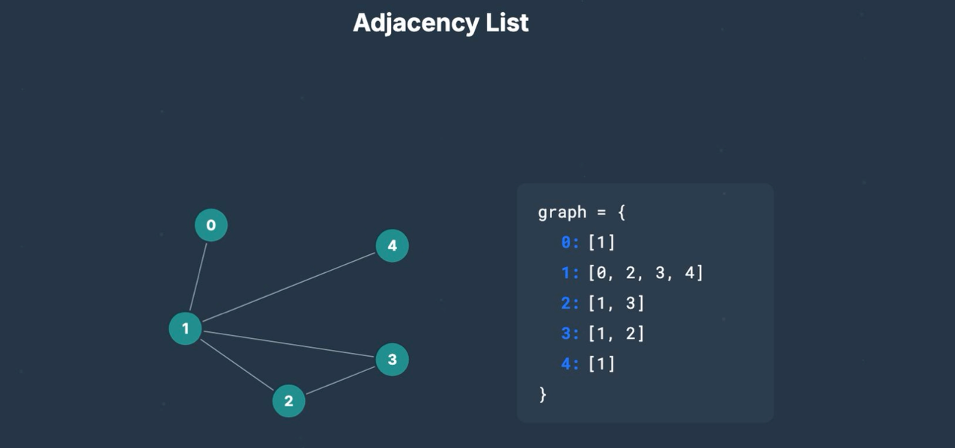
Graphs can be connected (there is a path between every pair of nodes) or disconnected (sometimes a graph can have separate pieces with no edges between them. Each piece is called connected component.) in this picture 2 connected components are there in one disconnected graph.
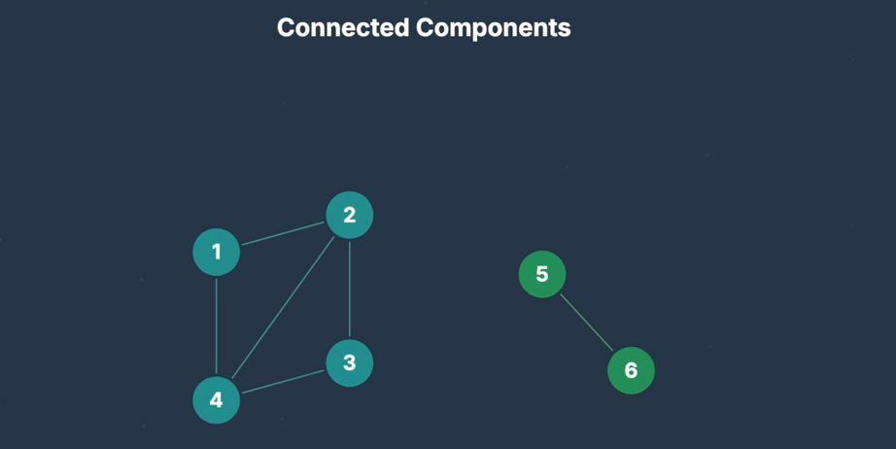

Graph BFS:
BFS is traversing level by level instead of going full depth in one side. Graph BFS is used for problems like shortest path and minimum node etc. To achieve this a queue and a set is used. First will add starting node into queue then will start below process
- Get the size(n) of the queue
- Iterate the loop n times – each iteration will remove the first element from queue and check if that node is already visited using set and then add all of its adjacent nodes(left, right, up, down) if those are not visited already.
These 2 steps will run until queue is not empty.

